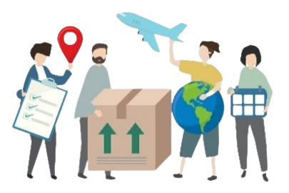

**Citizenship, Economics and Society**

**(Secondary 1-3)**

**Support Resources**

**Secondary 2**

**Module 2.4**

**Economic Performance and Human Resources of Hong Kong**

**Part 2:**

**Opportunities and Challenges brought by Economic Globalisation to**

**Hong Kong**

Personal, Social and Humanities Education Section

Curriculum Development Institute

Education Bureau

**Introduction**

* The “Citizenship, Economics and Society (Secondary1-3) Support Resources” covers the essential learning contents of Strands 1, 5 and 6 in the Personal, Social and Humanities Education Key Learning Area. It is designed to support the implementation of the Citizenship, Economics and Society curriculum.
* The support resources provide diversified learning activities to help

students acquire knowledge and understand concepts, develop skills

and nurture positive values and attitudes. In addition, they offer

teaching guidelines and suggestions on learning and teaching activities for teachers’ reference. Further, they provide reading materials to enhance students’ interest in reading.

* “Module 2.4 Economic Performance and Human Resources of Hong Kong Part 2: Opportunities and Challenges brought by Economic Globalisation to Hong Kong” for Secondary 2 was developed by the Personal, Social and Humanities Education Section, Curriculum Development Institute of the Education Bureau. Part of the contents of this resource is based on the learning and teaching materials developed by the Business School of the Chinese University of Hong Kong and Hong Kong Effective Teaching Association, commissioned by our section in 2019 and 2014 respectively.

**Module 2.4 Economic Performance and Human Resources of Hong Kong**

**Part 2: Opportunities and Challenges brought by Economic Globalisation to Hong Kong**

**Contents**

|  |  |
| --- | --- |
|  | **Page** |
| **Introduction to the Resource** | 5 |
|  |  |
| **Teaching Design** |  |
| Lesson 1 to Lesson 2: Understand the meaning of economic globalisation, factors contributing to economic globalisation and its impacts | 6 |
| Lesson 3 to Lesson 6: Opportunities and challenges brought by economic globalisation to Hong Kong as an international financial centre | 8 |
| Lesson 7: The role of Hong Kong in the economic development of our country under economic globalisation | 12 |
|  |  |
|  |  |
| **Learning and Teaching Activities** |  |
| Pre-lesson worksheet: How is economic globalisation related to us? | 13 |
| Worksheet 1: Characteristics of economic globalisation | 14 |
| Worksheet 2: Factors contributing to economic globalisation | 19 |
| Worksheet 3: What makes Hong Kong an international financial centre? | 31 |
| Worksheet 4: How does the Basic Law help Hong Kong keep  its financial market free and open? | 38 |
| Extended Case Study: Financial Sector in Hong Kong | 42 |
| Worksheet 5: Challenges facing Hong Kong as an international financial centre | 47 |
|  |  |
|  |  |
|  |  |
| **Self-learning Materials** |  |
| Online Learning: Globalisation | 26 |
| Extended Reading: China’s response to economic globalisation | 27 |
| Online Learning: Hong Kong as an international financial centre | 37 |
| Basic Law ABC | 41 |
| Extended Reading: Factsheets on “Outline of the 14th Five-Year Plan for National Economic and Social Development of the People’s Republic of China and the Long-Range Objectives Through the Year 2035”: International Financial Centre | 53 |
|  |  |
| **References** | 54 |

**Introduction to the Resource:**

This resource aims at introducing the meaning of economic globalisation, factors contributing to economic globalisation and its impacts to students. They will then understand the opportunities and challenges that economic globalisation has brought to the Hong Kong economy, including under economic globalisation, the status of Hong Kong as an international financial centre and the role of Hong Kong in the economic development of our country. These help students understand that strong support from the motherland and close connection with the world are Hong Kong’s distinctive advantages; and how Hong Kong integrates itself into our country’s overall development and serves well as the bridge for mutual connection and access between our country and the world, which will help students become the active forces driving the development of Hong Kong.

**Teaching Objectives:**

* To understand relevant knowledge of economic globalisation and international financial centre
* To develop and cultivate relevant generic skills, values and attitudes

**Learning Points:**

* understand the meaning of economic globalisation, factors leading to economic globalisation and its impacts;
* understand the opportunities and challenges brought by economic globalisation to the status of Hong Kong as an international financial centre;
* understand the role of Hong Kong in the economic development of our country under economic globalisation, Hong Kong’s distinctive advantages of strong support from the motherland and close connection with the world, as well as the need for Hong Kong to enhance its development momentum and serve well as the bridge for mutual connection and access between our country and the world;

**Suggested Number of Lessons:**

* 7 lessons (40 minutes each)

**Teaching Design**

|  |  |  |
| --- | --- | --- |
| **Topic:** | Opportunities and challenges brought by economic globalisation to Hong Kong | |
| **Duration:** | 7 lessons | |
| **Learning Objectives:** | * understand the meaning of economic globalisation, factors leading to economic globalisation and its impacts; * understand the opportunities and challenges brought by economic globalisation to the status of Hong Kong as an international financial centre; * understand the role of Hong Kong in the economic development of our country under economic globalisation, Hong Kong’s distinctive advantages of strong support from the motherland and close connection with the world, as well as the need for Hong Kong to enhance its development momentum and serve well as the bridge for mutual connection and access between our country and the world; | |
| **Lesson 1 and Lesson 2 (Understand the meaning of economic globalisation, factors leading to economic globalisation and its impacts)** | | |
| **Pre-lesson Preparation:** | The teacher distributes the “Pre-lesson worksheet: How is economic globalisation related to us?” to students before the lesson and asks them to finish it before sharing in the class. | |
|  |  | **Suggested lesson time** |
| **Enquiry Process:** | 1. **Set:**  * The teacher briefly introduces the contents of the seven lessons and invites students to share their findings in the “Pre-lesson worksheet: How is economic globalisation related to us?” Students should understand that globalisation is part of our daily life. | 10 minutes |
| 1. **Interactive teaching:**  * The teacher asks students to work in pairs to finish Question 1 of “Worksheet 1: Characteristics of Economic Globalisation” and share their answers with the class. Then the teacher uses “Knowledge Content: What is economic globalisation?” to explain to the students the meaning of globalisation and economic globalisation. Students will then work on Questions 2 and 3 to explore the cross-boundary economic activities that have taken place in Hong Kong and the benefits brought about by economic globalisation. The teacher explains to students the answers given by them. | 25 minutes |
| 1. **Summary:**  * The teacher reviews the key points in the “Knowledge Content: What is economic globalisation?” with students. | 5 minutes |
| 1. **Interactive teaching:**  * The teacher distributes “Worksheet 2: Factors contributing to economic globalisation” to students and divide the class into four groups. Students then work together in a jigsaw to read different pieces of information and analyse the factors contributing to economic globalisation. * The four groups of students share their discussion results and the teacher explains to students the answers given by them. | 25 minutes |
| 1. **Conclusion:**  * The teacher revises the key points in the “Knowledge Content: What is economic globalisation?” with students. * The teacher summarises what they have learnt and briefly explains the requirements of the homework. * The teacher briefly explains the “Knowledge Content: The impact of economic globalisation” and asks students to read “Extended Reading: China’s Reactions to Economic Globalisation” at home. | 15 minutes |
| **Homework:** | Students read the “Extended Reading: China’s reactions to economic globalisation” at home. | |
| **Learning and Teaching Resources:** | Pre-lesson activity; Worksheet 1 and 2; Extended Reading | |

|  |  |  |
| --- | --- | --- |
| **Lesson 3 to 6 (Opportunities and challenges brought by economic globalisation to Hong Kong as an international financial centre)** | | |
| **Lesson 3** | | |
|  |  | **Suggested lesson time** |
| **Enquiry Process:** | 1. **Set:**  * The teacher briefly revises the economic development of Hong Kong with students by asking them questions. | 5 minutes |
| 1. **Interactive teaching:**  * The teacher explains “Knowledge Content: Economic globalisation and the evolution of Hong Kong’s economy” and “Knowledge Content: What is an international financial centre?”. * The teacher distributes “Worksheet 3: What makes Hong Kong an international financial centre?” to students. They have to read Sources 1 to 3 and answer Question 1. The teacher invites students to share their answers and then further explains the answers. * The teacher asks students to read Source 4 and Source 5 and finish Question 2. Then the teacher invites students to share their answers and then further explains the answers. | 20 minutes |
| 1. **Conclusion:**  * The teacher reviews the key points in the “Knowledge Content: Favourable factors that promote the development of Hong Kong as an international financial centre” with students. | 15 minutes |
| **Homework:** | Students read the online learning and teaching resources at home. | |
| **Learning and Teaching Resources:** | Worksheet 3 | |

|  |  |  |
| --- | --- | --- |
| **Lesson 4** | | |
|  |  | **Suggested lesson time** |
| **Enquiry Process:** | 1. **Set:**  * The teacher stimulates students to think about the relationship between the Basic Law’s protection and Hong Kong’s status as an international financial centre by asking them questions. | 5 minutes |
| 1. **Interactive teaching:**  * The teacher distributes “Worksheet 4: How does the Basic Law help Hong Kong keep its financial market free and open?” to students. They have to read Source 1 and answer Questions 1 to 2. The teacher invites students to share their answers and then further explains the answers. * The teacher asks students to read Source 2 and finish Question 3 to 4. The teacher invites students to share their answers and then further explains the answers. | 25 minutes |
| 1. **Conclusion:**  * The teacher uses “Basic Law ABC” to revise the key points. | 10 minutes |
| **Homework:** | Students read the powerpoint “How does the Basic Law help Hong Kong keep its capitalist system?”(Chinese Only) at home. | |
| **Learning and Teaching Resources:** | Worksheet 4 | |

|  |  |  |
| --- | --- | --- |
| **Lesson 5** | | |
|  |  | **Suggested lesson time** |
| **Enquiry Process:** | 1. **Set:**  * Through asking questions, the teacher stimulates students to think about the importance of the financial industry to Hong Kong economy; as well as revises with students the definitions of some economic performance indicators. | 10 minutes |
| 1. **Interactive teaching:**  * The teacher distributes “Extended Case Study: Financial sector in Hong Kong” to students and asks them to read Sources 1-5 and finish Questions 1-4. The teacher invites students to share their answers and then further explains the answers.   *(Remark: Based on the ability of students and the teaching progress, the teacher may determine whether to conduct the “Extended Case Study: Financial sector in Hong Kong”.)* | 30 minutes |
| 1. **Conclusion:**  * The teacher briefly sums up and concludes the lesson. | 5 minutes |
| **Learning and Teaching Resources:** | Extended Case Study | |

|  |  |  |
| --- | --- | --- |
| **Lesson 6** | | |
|  |  | **Suggested lesson time** |
| **Enquiry Process:** | 1. **Set:**  * The teacher shows students pictures of landmark buildings of some international financial centres and lets them identify the cities those buildings are located. | 5 minutes |
| 1. **Interactive teaching:**  * The teacher distributes “Worksheet 5: Challenges facing Hong Kong as an international financial centre” to students. They have to read the information and answer the questions. The teacher invites students to share their answers and then further explains the answers. | 20 minutes |
| 1. **Conclusion:**  * The teacher uses “Knowledge Content: Challenges and outlook for Hong Kong as an international financial centre” to revise with students the key points. | 15 minutes |
| **Homework:** | Students browse websites about “Guangdong-Hong Kong-Macao Greater Bay Area” at home. | |
| **Learning and Teaching Resources:** | Worksheet 5; Knowledge Content: Challenges facing Hong Kong as an international financial centre | |

|  |  |  |
| --- | --- | --- |
| **Lesson 7 (The role of Hong Kong in the economic development of our country under economic globalisation)** | | |
|  |  | **Suggested lesson time** |
| **Enquiry Process:** | 1. **Set:**  * The teacher explains “Knowledge Content: The role of Hong Kong in the economic development of our country”. | 10 minutes |
| 1. **Interactive teaching:**  * The teacher plays the TV programme: “Vision of the Fourteenth National Five-Year Plan” Episode 1: Hong Kong’s New Vision (Chinese only), and let student know about the 14th Five-Year plan and the role of Hong Kong in the economic development of our country. | 20 minutes |
| 1. **Conclusion:**  * The teacher stimulates students to think about how Hong Kong can make use of its distinctive advantages and contribute to the development of our country. * The teacher briefly summarises the lesson content. | 10 minutes |
| **Homework:** | Students read the factsheets on “Outline of the 14th Five-Year Plan for National Economic and Social Development of the People’s Republic of China and the Long-Range Objectives Through the Year 2035: International Financial Centre” at home. | |
| **Learning and Teaching Resources:** | TV programme: “Vision of the Fourteenth National Five-Year Plan” Episode 1: Hong Kong’s New Vision (Chinese only); Knowledge Content: The role of Hong Kong in the economic development of our country | |

**Module 2.4 Economic Performance and Human Resources of Hong Kong**

**Part 2：Opportunities and challenges brought by**

**Economic Globalisation to Hong Kong**

 Through this activity, students understand that globalisation is part of our daily life

**(Lesson 1 and 2)**

**Learning and Teaching Materials**

**Pre-lesson Worksheet: How is economic globalisation related to us?**

1. What products or services are provided by international corporations/multi-national companies that we will come into contact with in our daily life?

|  |  |  |  |
| --- | --- | --- | --- |
| **Scope** | **Products/services** | **Company / Brand name** | **The country where the company based in** |
| Food | Examples:  Hamburgers, chocolates | Examples:  McDonald’s, Ferrero Rocher | Examples:  McDonald’s: US;  Ferrero: Italy |
| Electronic products | Examples:  Tablets, mobile phones | Examples:  Apple, Samsung | Examples:  Apple: US;  Samsung: Korea |
| Entertainment | Examples:  Foreign films, online games | Examples:  Disney, Nintendo | Examples:  Disney: US;  Nintendo: Japan |

**Pre-lesson Activity: (Challenge question)**

1. Identify a brand on the web which has the production processes of its products dispersed in different locations all over the world.

|  |
| --- |
| *For example:* |
| *The hardware and software of iPhone are designed in the US; some of the* |
| *components are made in Japan and Korea; they are assembled in China; and* |
| *the products are sold all over the world.* |

 Students can learn about the characteristics of economic globalisation by comparing family living in the 1970s and the 2020s.

**Worksheet 1:**

**Characteristics of Economic Globalisation**

Compare the two sources below and then answer the following questions.

**Source 1: In the 1970s**

Hi Chan, “Princess Chang Ping” will be played in Sunbeam Theatre this afternoon! Let’s go and see it together later! In the evening, we can also watch the ace programme “Enjoy Yourself Tonight” on Hong Kong TV. We shouldn’t miss it!”

Grandpa



Today, I went to a store of Chinese products and bought a lot of clothes for my grandchildren. It’s difficult to find foreign brands in that store. So all these clothes I bought are made in the Mainland. So beautiful!

Grandma



I’m quite interested in foreign news. It’s a pity that I can’t read real-time foreign news on the newspaper. I wish I could travel to foreign countries any time. But it’s not easy to get a visa. And I can’t afford and expensive plane tickets.



Father



I usually do all the housework myself. If we could have a domestic helper, it would be great!

Mother



Wow! This building block set is easy. It is fun!

Brother



Tangy pudding and other local snacks are my favourite! Yummy!

Younger Sister



Reading “Cowboy Comics” in my free time is my greatest entertainment!

Elder Sister



**Source 2: In the 2020s**

Miss Secretary, I’ve just seen the news on the tablet that the Vietnamese government has introduced a business-friendly policy. It’ll be good for our expansion. I plan to open another garment factory in Vietnam. The investment is estimated to be one million dollars. I’ll travel to Vietnam tomorrow and take a look. And please help me order the clothing materials in the Mainland and the garment machines in Cambodia, and then ship them to Vietnam!

Father



Mrs. Lee, I’ve just hired a foreign domestic helper. Now it’s very convenient for them to work in Hong Kong. The visa is done in no time! Now I have more free time. Let’s go and watch the latest Korean movie in the afternoon! And then we can go shopping in the newly opened Japanese department store!



Mother



It’s great to watch videos on my mobile phone while eating hamburger. So happy!



Younger Sister



I’ve just ordered the latest game on a US shopping site. It’ll be shipped to my home in a few days! So convenient!



Elder Sister

1. Compare the products and services in the 1970s with 2020s. What are the differences between them?

|  |  |  |
| --- | --- | --- |
|  | **In 1970s** | **In 2020s** |
| **Products**  (e.g. clothes, toys and food) | *1. Clothes were made in the Mainland or Hong Kong*  *2. Toys were rather simple e.g. toy blocks*  *3. Food products included a variety of local snacks* | *1. Clothes are produced in different parts of the world*  *2. Toys for children are electronic games of foreign brands*  *3. Food products come from different countries* |
| **Services**  (e.g. entertainments, domestic services and shopping services) | *1. Mother did the housework*  *2. Entertainment was watching traditional Cantonese operas and local TV productions*  *3. Newspaper was a main source of information* | *1. Many families employ foreign domestic helpers to do the housework*  *2. Entertainment is watching films from different countries*  *3. People get information and shop online through the Internet* |



**What is economic globalisation?**

At present, there is still no generally accepted definition of “globalisation”. Generally speaking, it is featured by the continuous decrease in the restriction of geographical barriers, which allows ordinary people to take part in more cross-regional activities. Globalisation is a multifaceted phenomenon that can be viewed from economic, political and cultural perspectives. We will focus on **economic globalisation** in this resource.

|  |
| --- |
| **Economic globalisation** means cross-boundary economic activities. Driven by a free economy and technological advancement, there has been a huge transaction volume of goods and services across countries. The rapid flow of factors such as labour, capital, information and technology across countries has further promoted a close connection among economies in the world. |

1. From the perspective of economic globalisation, give two examples to illustrate how Hong Kong’s economic activities have transcended boundaries and borders.

|  |
| --- |
| *Below are some examples illustrating how cross-boundary economic activities* |
| *take place in Hong Kong(any two examples from the following)* |
| * *We often use products and services produced in different parts of the* |
| *world / provided by multi-national companies.* |
| * *Labour in other countries may come to Hong Kong to work and we may* |
| *also work in other countries/ regions. There is labour mobility across* |
| *countries.* |
| * *We can invest internationally easily and capital flow has grown rapidly.* |
| * *We can easily get access to information of other places through* |
| *technologies such as the Internet. Information can flow rapidly.* |
|  |
|  |

1. How can we benefit from economic globalisation in our daily life?

|  |
| --- |
| *Economic globalisation allows us to access to more types of products and* |
| *services easier, gives us more choices and makes our lives more convenient.* |
|  |
|  |

**Worksheet 2:**

 Teachers may divide the class into four groups and use jigsaw teaching strategy, i.e. each group focuses on reading different materials and analysing the factors contributing to economic globalisation.

**Factors contributing to economic**

**globalisation**

**Reading Material A**

|  |  |  |  |  |  |  |  |  |  |  |  |  |  |  |
| --- | --- | --- | --- | --- | --- | --- | --- | --- | --- | --- | --- | --- | --- | --- |
| **Source 1**  With the development of communication technologies, time and space are no longer problems when we want to promote our products. People can get access to our latest information through channels such as TV and the Internet instantly. Our products can then draw their attention. In addition to promotion, our company has launched an online shopping platform so that consumers can buy our products comfortably at home.  Female manager  Head of Marketing Department of a multi-national company    **Source 2: Milestones of IT development**   |  |  |  |  | | --- | --- | --- | --- | | 1940s |  | The first electronic digital computer was developed |  | | 1950s | The first satellite was launched by the former Soviet Union | | 1960s | The first fax machine came into the world | | 1990s | World Wide Web | | 2000s | Web 2.0 came into being | | 2020s | More than 4 billion Internet users all over the world. The worldwide smartphone penetration rate exceeds 67%, and more than 5 billion people use mobile phones |   Source: Xinhua Net, Integrated news and Kemp, S. (2020). Digital 2020: Global Digital Overview. Retrieved from <https://datareportal.com/reports/digital-2020-global-digital-overview> |

**Reading Material B**

|  |  |  |  |  |  |  |  |  |  |  |  |  |  |  |  |  |  |  |
| --- | --- | --- | --- | --- | --- | --- | --- | --- | --- | --- | --- | --- | --- | --- | --- | --- | --- | --- |
| **Source 1**    Sea, land and air transport becomes more and more convenient when transportation cost is getting lower and lower. That makes us to be able to reach different places easier and faster. While we have established our production bases in places where production costs are much lower, huge volume of products can be transported to all parts of the world for sale conveniently. Moreover, we can conduct frequent on-site inspection to ensure the quality of products.  Head of Logistics Department of a multi-national company    **Source 2: Development of transport technologies**  The following table shows the speed of transport in different periods:   |  |  |  |  | | --- | --- | --- | --- | | **Period** | **Major transport** | **Speed** |  | | 1500s-1840s | Horse-drawn coaches and sailing ships | 1.6km/hr | | 1850s-1930s | Steam locomotive | 104km/hr | | Steam ships | 58km/hr | | 1930s-1950s | Propeller aircraft | 480-640km/hr | | 1960s-21st century | Jet passenger aircraft | 800-1120km/hr |   Source: Harvey (1989). The condition of postmodernity. p. 241. |

**Reading Material C**

|  |  |  |  |  |  |  |  |  |  |  |  |  |  |  |  |  |  |  |  |  |  |  |  |  |  |  |  |  |  |  |  |  |  |  |  |  |  |  |  |  |  |  |
| --- | --- | --- | --- | --- | --- | --- | --- | --- | --- | --- | --- | --- | --- | --- | --- | --- | --- | --- | --- | --- | --- | --- | --- | --- | --- | --- | --- | --- | --- | --- | --- | --- | --- | --- | --- | --- | --- | --- | --- | --- | --- | --- |
| **Source 1**    To boost our business, we invest worldwide and want to attract more talents to our company. We have published recruitment advertisements around the world in the hope of attracting top talents around the world to our US headquarter. Moreover, we will hire workers and supervisors from places where we operate our factories. As their wage level is lower, our production cost is substantially reduced.  Head of HR of a multi-national company    **Source 2: 2019 Average income around the world (Extract)**   |  |  |  | | --- | --- | --- | | **Ranking** | **Country / Region** | **Monthly average income per person (US$)** | | 1 | Monaco | 15507 | | 2 | Bermuda | 9811 | | 3 | Liechtenstein | 9703 | | 4 | Switzerland | 7125 | | 5 | Norway | 6875 | | 9 | United States | 5488 | | 12 | Singapore | 4966 | | 17 | Hong Kong, China | 4233 | | 45 | The Mainland of China | 868 | | 51 | Thailand | 605 | | 60 | Indonesia | 338 | | 66 | Vietnam | 216 | | 68 | India | 177 |   Source: WorldData.info. (2020). Average income around the world. Retrieved from https://www.worlddata.info/average-income.php (5 Mar 2021) |

**Reading Material D**

|  |  |  |  |  |  |  |  |  |  |  |
| --- | --- | --- | --- | --- | --- | --- | --- | --- | --- | --- |
| **Source 1**  We have been providing strong support to certain developing countries/regions in their economic development by ways such as policies favorable to foreign investors and improvement in infrastructure, we actively invest in these countries. With our supports, investors are eager to invest in these countries and this benefits the economic development of the countries.  Man in suit without face  Spokesman of an International Organisation    **Source 2: Functions of organisations for international cooperation (Extract)**   |  |  | | --- | --- | | **Organisation** | **Functions** | | World Trade Organization (WTO) | Establish trade agreements; resolve trade disputes; review trade policies. | | World Bank | Provide loans and technical support to developing countries. | | International Monetary Fund (IMF) | Foster global monetary cooperation; provide financial assistance to countries in need. | | Organization for Economic Co-operation and Development (OECD) | Foster sustainable economic development of member countries, promote free trade and foster the development of industrialised countries and developing countries. |     Source: Xinhua Net, Integrated local news |

1. With reference to the information above, summarise and explain the factors contributing to economic globalisation.

|  |  |  |
| --- | --- | --- |
| **Reading Material** | **Factors contributing to economic globalisation** | **Explanation** |
| A | *The advancement of Information technology(IT)* | * *With the development in IT (mass media like the Internet, TV and radio broadcasting, etc.), time and space are no longer problems in communications among people.* * *People can get to know the information of different regions with IT (especially the Internet) quickly.* * *Enterprises of different countries can also promote their products or even run businesses through these new technologies (especially the Internet) to make their products sell well worldwide.* * *Through mass media, people around the world can understand different cultures and bring regions closer to each other.* |
| B | *Development of transport technologies* | * *The continuous increase in cargo and passenger capacity, and speed of sea, land and air transportation has stimulated the flow of population, capital and resources across countries/regions and promoted the development of globalisation.* |
| C | *Mobility of labour and capital across countries* | * *In a globalised world, companies can raise funds in different regions and invest them into other countries conveniently.* * *With business networks around the world, multi-national corporations may hire labour or experienced talents from all parts of the world at lower wages.* |
| D | *Emergence of international organisations* | * *Intergovernmental bodies and international non-governmental organisations that promote free trade and economic development strengthen international cooperation in different aspects. They also serve as a bridge to global communication that promotes the development of globalisation.* |



**Factors contributing to economic globalisation**

Economic globalisation is a process. But its development has become more rapid since the 1990s. We can learn about factors contributing to economic globalisation in terms of information technology, transportation, and international organisations.

1. **Development of information technology**

In terms of information technology development, the Internet developed rapidly in the early 1990s. People from all over the world can exchange and communicate through the Internet, promoting global economic and trade development. For example, with the development of technology, people can conduct financial or commerce transactions through various online trading platforms. Both multi-national companies and individuals can conduct transactions with people around the world on the Internet and with various electronic monies. Technological development has made this transaction mode more convenient and low-cost. It helps various trading companies and consumers around the world to conduct transactions.

1. **Development of transportation**

The development of transportation and logistics has facilitated the rapid flow of talents and commodities around the world. Countries can negotiate business and trade more effectively, quickly and at a lower cost. People can work in different places. And cross-border trade has become more convenient.

1. **Emergence of international organisations**

The establishment of many transnational economic organisations has also contributed to economic globalisation. For example, international economic cooperation organisations such as the World Trade Organisation and the Asia-Pacific Economic Cooperation are committed to removing trade barriers and strengthening cooperation for more comprehensive economic exchanges.



**Impacts of economic globalisation**

Economic globalisation brings an increase in total goods and services produced in the world, though there may be an uneven distribution of benefits. Some of them may benefit more while some of them may suffer. For example, economic globalisation brings more job opportunities and improves the lives of people in developing countries. It also brings technologies and capital to developing countries to help them shake off poverty in the long run. From the perspective of developed countries, economic globalisation helps companies outsource the production processes to lower their production costs, while consumers can buy what they need at a lower price. Outsourcing low-skilled production processes help developed countries to have economic transformation and to develop their high value-added industries.

While economic globalisation brings job opportunities to developing countries, workers are usually facing exploitation as manufacturers seek to curb their production costs. As a result, their pay and working conditions are usually far from satisfactory. For the people in developed countries, even if they can gain access to products at lower prices, their jobs may be taken away by people from the developing countries. The operating costs of small and medium-sized enterprises in many developed countries are far higher than those in developing countries. As a result, many of them shut down simply because they are less competitive. Thus, the developed countries may have to deal with the problem of serious unemployment and uneven income distribution. Moreover, countries are more interdependent, and the ups and downs of an economy may affect the other countries as well.

**Online Learning: Globalisation**

1. Students may watch the following video to understand what is globalisation and economic globalisation.

 Globalisation, EDB Educational Multimedia

<https://emm.edcity.hk/media/1_96apa2wy>

**Extended Reading: China’s response to economic globalisation**

Since the beginning of reform and opening-up, our country has continuously improved its economic strength with its abundant labour force and huge consumer market. Now it has become the second largest economy in the world. Over the years, our country has implemented a number of measures to cope with the opportunities and challenges brought about by economic globalisation.

**Entry into the WTO:**

* After accession to the World Trade Organisation (WTO) in 2001, the Central Government amended relevant local regulations and legislation in accordance with WTO requirements, so as to further promote opening up and integrate with the global economy.

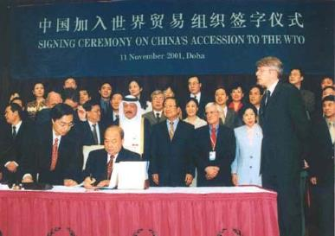

# Source: WTO web page

<https://www.wto.org/images/img_10anniv/phf_500.jpg>

* For example, our country has fully honoured its WTO commitments by lowering import tariffs from 15.3% (before China’s accession to WTO) to 7.5% in 2018, a remarkable decrease of 51%.
* After its entry into the WTO, our country has provided access opportunities for overseas service providers in finance, telecommunications, construction, distribution, logistics, tourism, education, etc. And our country has opened 100 out of the 160 service sectors classified by the WTO.

**Promotion of the “Belt and Road” Initiative**

* President Xi Jinping proposed the “Belt and Road” initiative in 2013 as a new model for international cooperation. Combining the advantages of countries located along the routes, the initiative promotes cooperation and communication among participating nations in a large number of areas. At the same time, it facilitates the joint development and constructive economic cooperation with openness, inclusiveness, balance and mutual benefit attitude.
* In 2015, the National Development and Reform Commission, the Ministry of Foreign Affairs and the Ministry of Commerce jointly released the “Vision and Actions on Jointly Building Silk Road Economic Belt and 21st-Century Maritime Silk Road”. In 2017 and 2019, China held the Belt and Road Forum for International Cooperation on two occasions, signing cooperation agreements with many countries and international organisations to enhance its opening up to the outside world.

**Founding of and participating in international economic organisations**

* After the beginning of reform and opening-up, our country has regained its legal seats in the International Monetary Fund and the World Bank.
* And it has joined the Asia-Pacific Economic Cooperation and the Asian Development Bank successively.
* Besides, it has formed the Shanghai Cooperation Organisation with Central Asian countries and Russia to promote regional economic cooperation in Asia.

Source: The Academy of Chinese Studies. <https://ls.chiculture.org.hk/tc/idea-aspect/480> (in Chinese)

**Module 2.4 Economic Performance and Human Resources of Hong Kong**

**Part 2：Opportunities and challenges brought by**

**Economic Globalisation to Hong Kong**

**(Lesson 3 to 6)**

**Learning and Teaching Materials**



**Economic Globalisation and the Evolution of Hong Kong’s Economy**

Under globalisation, Hong Kong has always been looking for something with advantages for development and transformation. The city evolved from a trade entrepot to a manufacturing centre, and then quickly to an industrial city. Finally it has become an international financial centre today. Among others, Hong Kong's economic take-off after the 1970s has been related to the globalisation of production. After the mid-1970s, developed countries in the West started subcontracting labour-intensive processes to regions with lower cost and the “Four Asian Tigers” benefited a lot. Hong Kong’s manufacturing industry was growing rapidly at this time. Among others, the consumer goods oriented light industry was the major player in the manufacturing industry. Garments, consumer electronics, toys were always the major output in Hong Kong’s industry. However, starting in the mid-1980s, local manufacturers were caught in a dilemma due to high production costs and competition from other emerging industrial economies (such as Thailand and Indonesia). Hong Kong manufacturers began to look for more profitable development opportunities overseas. Reallocation of production processes to the north was the leading production strategy for the manufacturing firms. (For more details, please refer to the module of “Economic Performance of Hong Kong”)

On the other hand, the trend of globalisation has stimulated the internationalisation of financial markets. Local investors can trade in overseas markets, and vice versa. As an international financial centre, Hong Kong needs to provide diversified services and products to cater for the needs of overseas market participants.

Source:

Department of Sociology, The Chinese University of Hong Kong <https://www.cuhk.edu.hk/hkiaps/pprc/LS/globalization/2_c.htm> (in Chinese)

*How to Consolidate Hong Kong's Status as an International Financial Centre* <https://www.info.gov.hk/gia/general/200312/16/1216092.htm> (in Chinese)

Note: This Resource focuses on the impacts of globalisation on Hong Kong’s financial services industry.



**What is an international financial centre?**

An international financial centre is generally defined as a place in which there is a high concentration of banks and other financial institutions, and in which a comprehensive set of financial markets are allowed to exist and develop, so that financial activities and transactions can be effectuated more efficiently than at any other locality.

Source: Hong Kong Monetary Authority (<https://www.hkma.gov.hk/media/eng/publication-and-research/quarterly-bulletin/qb200712/E_05_12.pdf>)

**Concept Recap: What services do the financial institutions provide?**

Services provided by financial institutions include deposits and loans, insurance, foreign exchange trading, mortgages, and securities trading etc.

[Note: For various financial services provided by banks and other financial institutions, please refer to the Secondary 1 support materials, “Resource 9: Financial Education”.]



Appendix 1

**Know More**

Over the past two decades, Hong Kong's status as an international financial centre has also become more prominent. In the mid-1990s, many mainland companies came to Hong Kong for public listing and fund raising. Today, the funds in the Mainland market and those in the international market are difficult to merge directly due to institutional differences. **Hong Kong’s financial markets operate under effective and transparent regulations** that are in line with **international standards**. As an intermediary (between overseas and the Mainland), Hong Kong introduces overseas funds into the Mainland market while enabling the investment of Mainland funds in the local stock market as per international regulations. It greatly **enhances the internationalisation of the Mainland market**.

**Worksheet 3: What makes Hong Kong an international financial centre?**

**Source 1: The number of Global 500 multi-national corporations that have their headquarters located in London, New York and Hong Kong and the number of financial institutions in Hong Kong**

|  |  |
| --- | --- |
|  | International financial institutions maintain a strong presence in Hong Kong. Of the world’s top 100 banks, 78 operate in the city. At the year end of 2021, 151 of the 160 licensed banks in Hong Kong were beneficially owned by parties outside Hong Kong. |

Source:

Chapter 4: Financial and Monetary Affairs, Hong Kong Year Book 2021 <https://www.yearbook.gov.hk/2021/en/pdf/E04.pdf>

Fortune Magazine. (2019). *Global 500*. Retrieved from <https://fortune.com/global500/2018/search/>

**Source 2: Status of Hong Kong’s financial market**

|  |
| --- |
|  |
| An assessment report published by the International Monetary Fund in June 2021 reaffirmed that Hong Kong is a major international financial centre with sound macroeconomic and prudential policies, robust regulatory and supervisory frameworks, and important buffers to cope with economic slowdown and future shocks. It recognised efforts by the authorities to strengthen and upgrade the financial infrastructure, including addressing the risks of climate change and promoting Hong Kong as a financial technology (fintech) hub in Asia.  To strengthen its competitiveness in financial services, Hong Kong improves the regulatory framework, promotes market development and the application of fintech to increase productivity, enhances financial inclusion and drives green and sustainable development. |

Source: Hong Kong Year Book 2021: <https://www.yearbook.gov.hk/2021/en/pdf/E04.pdf> (Chapter 4 Financial and Monetary Affairs)

<https://www.hkeconomy.gov.hk/en/pdf/Business_report_2021.pdf>

**Source 3: Hong Kong Financial Service Sector at a Glance (Extracted)**

|  |  |  |
| --- | --- | --- |
|  | 2019  (USD bn) |  |
| Market Capitalisation of the Stock Market | 4,918 | * Global number 1 in IPO (initial public offering)* fundraising in 7 out of last 11 years |
| Bond Issuance | 560 | * Number 3 in Asia ex-Japan, after the Mainland of China and Korea |

Source: Hong Kong Monetary Authority: <https://www.hkma.gov.hk/eng/key-functions/international-financial-centre/hong-kong-as-an-international-financial-centre/>

*Remark:  IPO refers to the process of offering shares of a company to the public in a new stock issuance, which aims to raise capital.

1. Based on the above information, what features of international financial center does Hong Kong possess?

|  |  |  |
| --- | --- | --- |
|  | Related Features | Illustration |
| Source 1 | *Numbers of international financial institutions and multi-national corporations* | *Many international financial institutions and multi-national corporations set up branches in Hong Kong, showing the importance of Hong Kong in the world.* |
| Source 2 | *Economic policies and supervisions* | *Hong Kong has sound macroeconomic and prudential policies, robust regulatory and supervisory frameworks, and important buffers to cope with economic slowdown and future shocks.* |
| Source 1 and Source 3 | *Volume of trade of Hong Kong Financial Service Sector* | *There are a lot of financial institutions in Hong Kong. Various types of financial business, including IPO fundraising and bond issuance, are of world class.* |

**Source 4: Hong Kong’s International Financial Centre Status**

|  |
| --- |
| Situated at the heart of Asia, Hong Kong is within a five‑hour flight to key markets in the region and half the world’s population. The city’s trading system plugs fully into the round‑the‑clock global financial trading cycle and provides stable and seamless connectivity with other major financial hubs. Moreover, as part of China, Hong Kong has close geographical, cultural and linguistic links with the Mainland, while retaining its distinctive international elements.  The development of Hong Kong’s financial services industry has been supported by the Central People’s Government. The National 14th Five‑Year Plan, promulgated in March 2021, acknowledges the significant functions and positioning of Hong Kong in the overall development of the country. It supports Hong Kong to enhance its status as an international financial centre as well as deepen the mutual access between the financial markets of Hong Kong and the Mainland. Leveraging on its unique advantage of ‘one country, two systems’, Hong Kong will continue to be a bridge between the Mainland and the world.  Hong Kong’s status as an international financial centre is also underpinned by institutional strengths, which include the rule of law, an independent judiciary, open market, free flow of capital and a low and simple tax regime. Hong Kong’s financial market is characterised by deep liquidity, strong emphasis on investor protection, a well‑educated and highly efficient workforce and ease of entry for non‑local professionals. |

Source:

Hong Kong Year Book 2021: <https://www.yearbook.gov.hk/2021/en/pdf/E04.pdf> (Chapter 4 Financial and Monetary Affairs)

**Source 5: Hong Kong’s Distinctive Status and Advantages**

|  |
| --- |
| …Fourth, we must maintain Hong Kong's distinctive status and advantages. The central government has always handled Hong Kong affairs from a strategic and overall perspective, taking into consideration the fundamental and long-term interests of Hong Kong and the country as a whole. The fundamental interests of Hong Kong are in line with those of the country, and the central government and Hong Kong compatriots share the same aspirations. Hong Kong's close connection with the world market and strong support from the motherland are its distinctive advantages. Such favorable conditions are cherished by the people of Hong Kong and by the central government as well. The central government fully supports Hong Kong in its effort to maintain its distinctive status and edges, to improve its presence as an international financial, shipping, and trading center, to keep its business environment free, open, and regulated, and to maintain the common law, so as to expand and facilitate its exchanges with the world. On the country's journey toward building a modern socialist country in all respects and realizing the rejuvenation of the Chinese nation, the central government believes that Hong Kong will make great contributions. |

Source:

Xi Jinping's address at the meeting celebrating the 25th anniversary of Hong Kong's return to the motherland and the inaugural ceremony of the sixth-term government of the Hong Kong Special Administrative Region (Extract)

<https://english.news.cn/20220702/74d848898c8d4201bd5140570611dc58/c.html>

1. Based on the above, are the following favourable factors for Hong Kong to become an internationalfinancial centre?

|  |  |  |
| --- | --- | --- |
|  | Yes | No |
| 1. Superior geographical location | ✓ |  |
| 1. The government filters market information |  | ✓ |
| 1. Open market, free flow of capital and information | ✓ |  |
| 1. The regulatory system of the financial market is highly transparent and in line with international standards. | ✓ |  |
| 1. Talents gathered through education training and immigration policies | ✓ |  |
| 1. It maintains close ties with the mainland market and attracts overseas investors to invest in the mainland via Hong Kong | ✓ |  |
| 1. The financial system of Hong Kong is the same as those in other Mainland cities |  | ✓ |



**Favourable Factors that promote the Development of Hong Kong as an International Financial Centre**

In addition to characteristics of other international financial centres around the world (such as booming economic activities, free flow of funds and information, etc.), Hong Kong also enjoys a number of favourable factors for being an international financial centre.

1. **Superior geographical location**

Hong Kong is blessed with a superior location in a time zone between London and New York. As a result, global investors can trade in Hong Kong when markets in the other cities are closed, enabling international financial trading around the clock. Hong Kong is a hub connecting the northern and the southern parts of Asia. And it is an important export trade base for the Mainland (especially the Pearl River Delta region). Those factors are all conducive to Hong Kong’s provision of high value-added financial services facilitating the economic development of Asia and the Mainland.

1. **Good investment environment**

Hong Kong has sound legal and financial regulatory systems, to ensure that the interests of market participants are protected and the financial market operates smoothly. In addition, Hong Kong is known as the freest economy, without foreign exchange controls. And the city is one of the most corruption-free places in the world. All those factors are attractive to investors intending to conduct financial activities in Hong Kong.

1. **Simple and low tax system**

Hong Kong practises a simple and low-rate tax system. It collects fewer taxes at generally lower rates compared with Mainland China and other developed countries. Therefore, multi-national companies are attracted to invest in Hong Kong.

1. **Advanced communication equipment**

With Hong Kong’s advanced technology and communication development, well-equipped hardware facilities, and freedom of information, investors can access to information around the world and make appropriate investment decisions. Advanced communication equipment helps multi-national financial companies to communicate with each other, which promotes exchanges and also boosts the development of the financial industry.

1. **Excellent human resources**

The Hong Kong government is committed to expanding tertiary education. Many tertiary institutions offer programmes related to the financial industry to train talents with professional financial for the city. In addition, the education level of Hong Kong citizens has generally improved. Members of the public have a deeper understanding of the development and operation of the financial market. Individuals and organisations also know how to seek professional advice and appropriately use resources provided by the financial services sector to assist in asset management.

1. **Close connection with the world market and strong support from the motherland**

Since the implementation of the reform and opening-up in 1978, our country’s economy has been developing rapidly, attracting many Hong Kong and foreign businessmen to invest there. In the process, they need the financial services sector to provide various investment services and to make financing arrangements. Therefore, Hong Kong has become a bridge for Sino-foreign trade, which drives the development of Hong Kong’s financial industry.

**Online Learning: Hong Kong as an international financial centre**

1. Students may watch the following video to review the contents concerning “Hong Kong as an international financial centre”. (Chinese only)

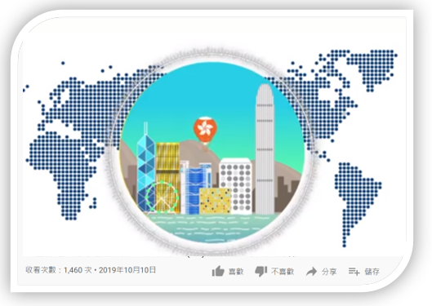

 Hong Kong as an international financial centre, EDB Educational Multimedia

<https://emm.edcity.hk/media/1_zno5pjdc>

2. Students may browse the websites of the following financial regulators to learn about their work:

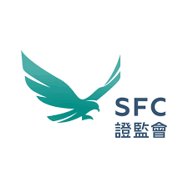Securities and Futures Commission (SFC)

https://www.sfc.hk/en/

Hong Kong Monetary Authority (HKMA)

<https://www.hkma.gov.hk/eng/>

**Extended Reading**

HKMA – International Financial Centre

<https://www.hkma.gov.hk/eng/key-functions/international-financial-centre/>

HKMA – Hong Kong as an International Financial Centre

https://www.hkma.gov.hk/eng/key-functions/international-financial-centre/hong-kong-as-an-international-financial-centre/

**Worksheet 4: How does the Basic Law help Hong Kong keep its financial market free and open?**

**Source 1: The Basic Law and Hong Kong Status as an International Financial Centre**

|  |
| --- |
| The financial industry is an important pillar of Hong Kong’s economy. It has made remarkable achievement internationally and is helping to keep Hong Kong prosperous. The following two Articles of the Basic Law clearly states that:  Article 109  *“The Government of the Hong Kong Special Administrative Region shall provide an appropriate economic and legal environment for the maintenance of the status of Hong Kong as an international financial centre.”*  Article 110 (2)  *“The Government of the Hong Kong Special Administrative Region shall, on its own, formulate monetary and financial policies, safeguard the free operation of financial business and financial markets, and regulate and supervise them in accordance with law.”* |

1. Which of the following 10 conditions do you think are related to free and open financial markets? Which contribute to a sound and stable system? Put down the corresponding numbers in the spaces below.

|  |  |
| --- | --- |
| 1. Capital can flow in and out freely | 1. Free flow of information |
| 1. Good communications network | 1. Foreign banks can join in freely subject to the legal requirements |
| 1. Strong and reliable banks | 1. Stable foreign exchange rates |
| 1. Strict regulations on the banking industry | 1. Robust legal structure |
| 1. Beautiful environment | 1. Highly transparent government |

|  |  |
| --- | --- |
| Conditions for “free and open financial markets” | *1，2，4* |
| Conditions for “a sound and stable system”: | *6，7，8，10* |

1. The financial industry also needs the support of other industries. Vibrant financial activities have a great demand for other commercial services. Hong Kong’s implementation of a free and open financial market has promoted the development of other service industries and created many job opportunities for Hong Kong people. Refer to the following diagram. Which industries are related to the financial industry? Please fill in their relevant names in the blanks provided.

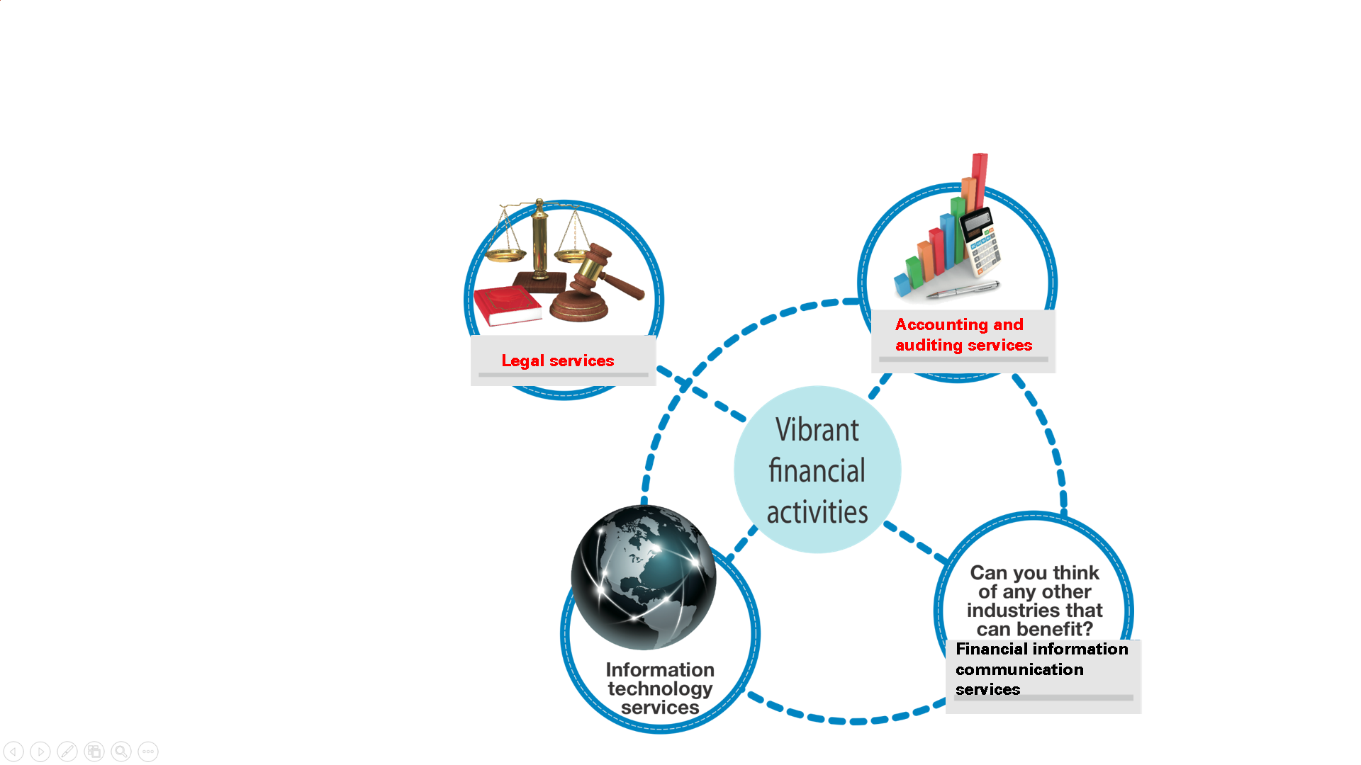

**Legal services**

**Information technology services**

**Financial information communication services**

**Accounting and auditing services**

**Source 2: Basic Law and Foreign Exchange Control**

|  |
| --- |
| The price of a foreign currency is also known as the exchange rate. (For instance, Country A needs to buy 1 US dollar with 10 local dollars.) Foreign exchange control means government controls the buying and selling of foreign currencies and their quantity supplied. People cannot buy their chosen currency and targeted quantity as they wish. (For example, the government of Country A restricts that its people can only exchange for foreign currency not exceeding a certain amount in a certain period of time.)  Some countries or regions impose foreign exchange control, but Hong Kong has no such policy. This is a clear provision in Article 112 of the Basic Law.  Article 112  *“No foreign exchange control policies shall be applied in the Hong Kong Special Administrative Region. The Hong Kong dollar shall be freely convertible. Markets for foreign exchange, gold, securities, futures and the like shall continue.*  *The Government of the Hong Kong Special Administrative Region shall safeguard the free flow of capital within, into and out of the Region.”*  The Basic Law stipulates that foreign exchange control policies shall not be applied in Hong Kong. Free and open financial markets such as banking, securities, futures, gold, etc. flourish in Hong Kong. Many foreign companies and large international financial institutions do their businesses in Hong Kong. |

1. Suppose you go to Japan as a visitor. Can you shop there with HK dollars? If no, what can you do?

|  |
| --- |
| *No. You have to exchange HK dollar for Japanese Yen in a bank or foreign* |
| *exchange shop.* |
|  |

1. Suppose there is foreign exchange control in Hong Kong. You cannot exchange HK dollar for other currencies. What would happen to the following people? Link up the circles and show the consequences.





Hong Kong overseas students

Overseas investor in Hong Kong

Hong Kong investors who wish to invest overseas

Local importers and consumers

Hard to buy imported foreign goods

Hard to exchange profits made in Hong Kong for foreign currency for transfer to home country

Hard to obtain foreign currency for daily needs overseas

Hard to invest overseas even if there are good opportunities

**Basic Law ABC**

The Basic Law helps Hong Kong keep the financial market free and open. Hong Kong is thus able to retain its status as an international financial centre after reunification. The financial industry is one of the four economic pillars of Hong Kong and contributes to the city’s economic prosperity.

However, with the benefits comes also the high cost. A free and open market allows a large amount of capital to flow in and out of Hong Kong quickly. The large fluctuations so caused in the financial market can exert a tremendous impact on a small economy. Sound regulations and a strong oversight system are necessary. Such requirements are set out in the Basic Law.

Note: If you want to know more about how does Hong Kong keep its role as an international financial centre, you may make reference to the powerpoint “How does the Basic Law help Hong Kong keep its capitalist system?”(Chinese Only).

<https://www.edb.gov.hk/tc/curriculum-development/kla/pshe/basic-law-education/constitution-basiclaw/index.html>

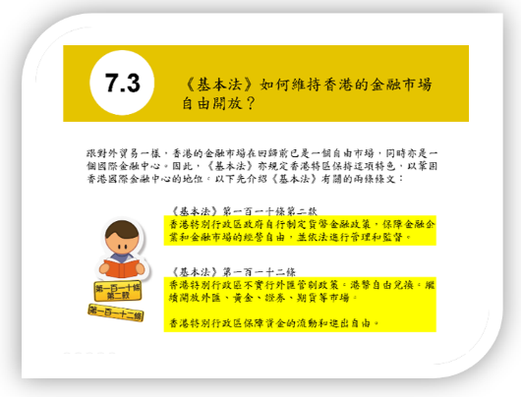

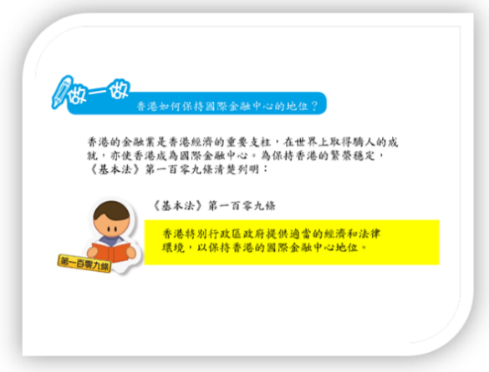

**Extended Case Study: Financial Sector in Hong Kong**

**Source 1: The percentage of GDP by key industries of Hong Kong in 2010 and 2020**

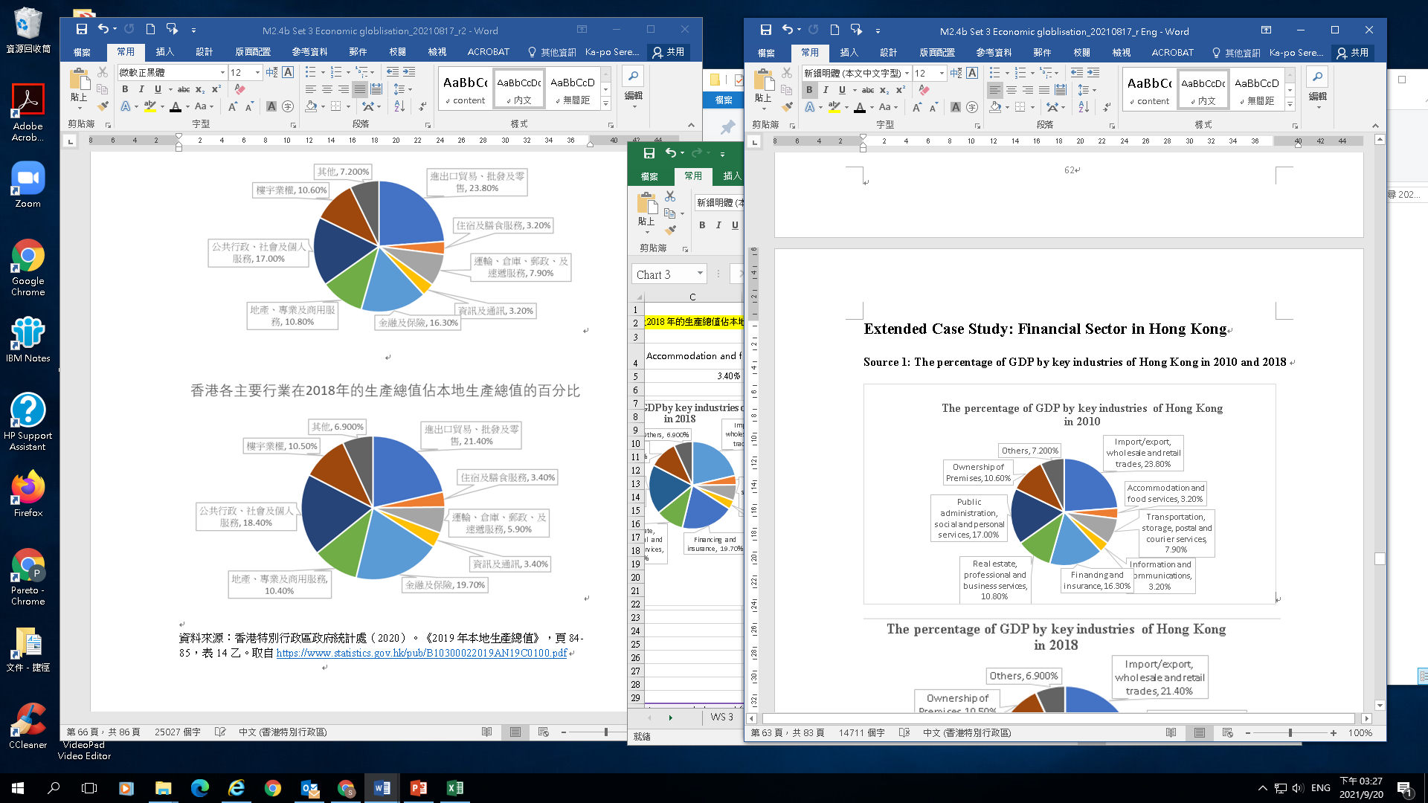

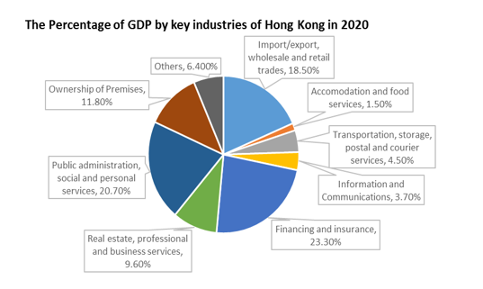

Source: Gross Domestic Product (Yearly) (2021 Edition), Census and Statistics Department

<https://www.statistics.gov.hk/pub/B10300022019AN19E0100.pdf>

**Source 2: Employed population in “financing and insurance industry” and in “all industries” in Dec 2010 and 2021**

|  |  |  |
| --- | --- | --- |
| Employed population | Dec 2010 | Dec 2021 |
| in “financing and insurance industry” | 196 413 | 238 710 |
| in “all industries” | 2 559 240 | 2 687932 |

Source: Number of Establishments, Persons Engaged and Vacancies (other than those in the civil service) Analysed by Industry Section, Census and Statistics Department (2022)

<https://www.censtatd.gov.hk/hkstat/sub/sp452.jsp?tableID=017&ID=0&productType=8>

**Source 3**

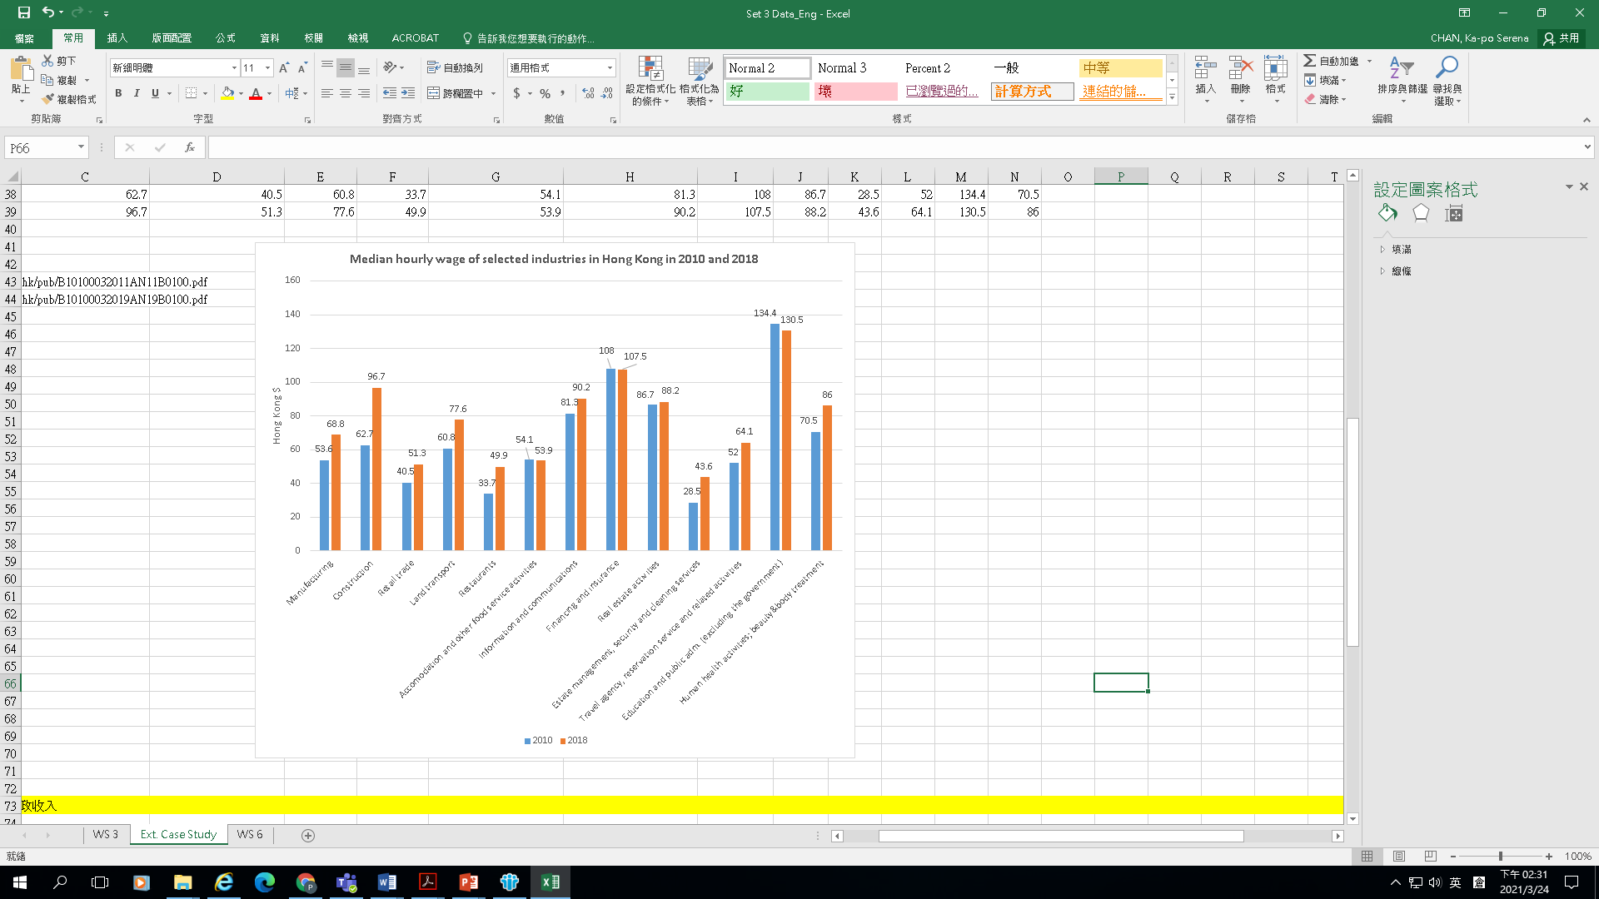

Source: Hong Kong Annual Digest of Statistics (2019 and 2011 Editions), Census and Statistics Department

**Source 4: Total Government revenue 1996 to 2020**

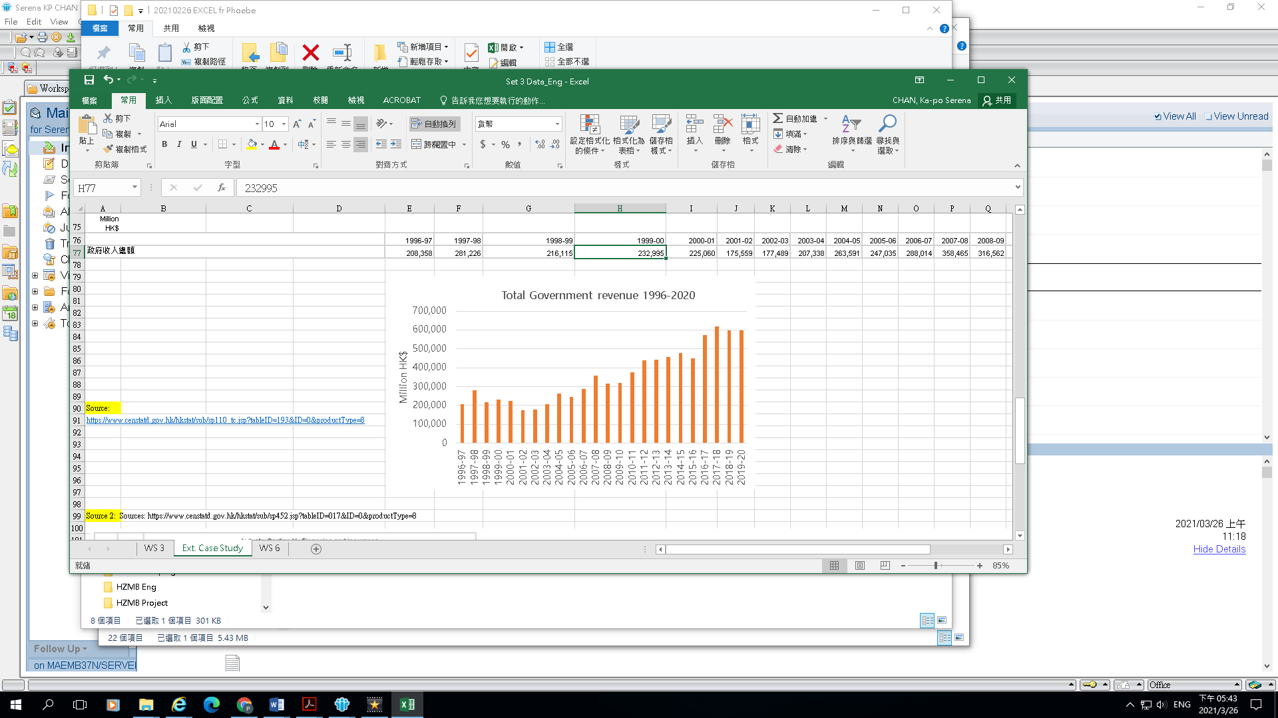

Asian financial crisis

Global financial tsunami

Figures for 2019-20 are subject to audit by the Director of Audit.

Source: Census and Statistics Department https://www.censtatd.gov.hk/hkstat/sub/sp110_tc.jsp?tableID=193&ID=0&productType=8

**Source 5: Local News**

|  |
| --- |
|  |

Source: eElderly webpage (2012) and Legislative Council Secretariat

Answer the following questions based on the above information.

1. According to Sources 1 and 2, how important is the financing and insurance industry to Hong Kong economy and labour market?

|  |
| --- |
| *The financing and insurance industry is very important to Hong Kong’s* |
| *economy. Its output accounted for 19.7% of Hong Kong’s GDP in 2018,* |
| *significantly up from 16.3% in 2010. In terms of GDP contributions by major* |
| *industries, its ranking rose from the third to the second. Moreover, the financing* |
| *and insurance industry creates employment opportunities for Hong Kong and* |
| *the number of people employed accounts for nearly one-tenth of the employed* |
| *population. The proportion of employed persons increased from 7.67% in 2010* |
| *to 8.46% in 2019. This means that the financing and insurance industries* |
| *generate a lot of income for Hong Kong, but it provides a relatively low* |
| *percentage of job opportunities for the local labour market.* |
|  |
|  |
|  |

1. According to Source 3, how do you think the income of employees in the financing and insurance industry is different from that in other industries? Try to compare the data of two years.

|  |
| --- |
| *According to Source 3, the income of employees in the financing and insurance* |
| *industry dropped slightly in 2018 compared with 2010. However, in both 2010* |
| *and 2018, the median hourly wage of employee in the sector ranked second* |
| *among major industries. It can be seen that the income is high in the financing* |
| *and insurance industry.* |
|  |
|  |
|  |
|  |
|  |

1. The financial industry has become an important economic pillar of Hong Kong. Based on Sources 4 and 5, point out the potential risk of this fact on the government and local residents.

|  |
| --- |
| *Hong Kong's financial industry is closely connected with overseas economies.* |
| *Economic turmoil or recession in other places will also affect the local financial* |
| *market.* |
| *A crisis in the Hong Kong financial market will have negative impacts on local* |
| *residents and the government. For example, residents will be faced with* |
| *investment losses, falling house prices, reduced wages or even unemployment.* |
| *As a result, they will have less money to spend and their quality of life will* |
| *decline. An economic downturn will also reduce the government's tax revenue* |
| *and weaken its ability to provide social welfare and services.* |
|  |

1. Why does Hong Kong need to consolidate its status as an international financial centre? As an international financial centre, how can Hong Kong embrace global competition and deal with the impact of economic fluctuations?

|  |
| --- |
| *The financial industry brings benefits to the Hong Kong economy. It can* |
| *promote the development of other industries, such as business services,* |
| *information technology, and tourism. And spending by employees in the* |
| *financial industry can also create job opportunities for the retail sector. At* |
| *present, finance is one of the four pillar industries in Hong Kong, playing an* |
| *important role in the development of the city’s economy.* |
| *In the face of global competition, Hong Kong should stabilise its financial* |
| *system and strengthen its development, in order to consolidate its position as* |
| *an international financial centre. However, in addition to developing the* |
| *financial industry, Hong Kong should also explore other sectors to diversify its.* |
| *industries and ensure a more balanced economic development* |
|  |
|  |

**Worksheet 5: Challenges facing Hong Kong as an international financial centre**

**Source 1: Ranking of the Global Financial Centres Index (GFCI)**

|  |  |  |  |  |  |
| --- | --- | --- | --- | --- | --- |
| Year | **New York** | **London** | **Hong Kong** | **Singapore** | **Shanghai** |
| 2016 | 2 | 1 | 4 | 3 | 16 |
| 2017 | 2 | 1 | 3 | 4 | 6 |
| 2018 | 1 | 2 | 3 | 4 | 5 |
| 2019 | 1 | 2 | 3 | 4 | 5 |
| 2020 | 1 | 2 | 5 | 6 | 3 |
| 2021 | 1 | 2 | 3 | 4 | 6 |
| 2022 | 1 | 2 | 3 | 6 | 4 |

Source:

China Development Institute (CDI) in Shenzhen and Z/Yen Partners in London. The Global Financial Centres Index 20.

1. Based on Source 1, which two cities have held a firm position as international financial centres?

|  |
| --- |
| * *London and New York* |
| * *They have been the two top financial centres in the world from 2016 to* |
| *2022* |

**Source 2: Five main factors affecting the Global Financial Centres Index (GFCI)**

|  |  |
| --- | --- |
| **Factors** | **Examples** |
| 1. Business Environment | The quality of the legal system, stability of business environment and international standards, economic freedom etc. |
| 1. Financial Sector Development | The effect of financial business clusters, transaction values of the capital market and other financial markets, etc. |
| 1. Infrastructure | Price of office space, transportation and feasibility, etc. |
| 1. Human Capital | Quality and skills of business education, the flexibility and free movement of labour, etc. |
| 1. Reputation | Brand innovation and attractiveness, cultural diversity, etc. |

Integrated sources, including:

China Development Institute (CDI) in Shenzhen and Z/Yen Partners in London. The Global Financial Centres Index 27.

<http://en.cdi.org.cn/images/research/gfci/GFCI_27_Full_Report.pdf>

1. Which factor in Source 2 is reflected in each of the news reports below? Fill in the corresponding letter in the box.

|  |  |
| --- | --- |
| Relevant factor | News report |
| C |  |
| B |  |
| A/E | Note:  A higher corruption perception index corresponds to a lower level of corruption |
| E |  |
| D |  |
| B |  |

1. A CEO of a multi-national financial institution is considering whether to maintain Hong Kong as its Asian headquarter. How do you think the factors affecting the GFCI ranking will influence his/her decision? (Hints: (1) What are the five major factors affecting the GFCI? (2) Will changes in the rankings of Hong Kong and other places influence his/her decision?)

|  |
| --- |
| * *Being the CEO of a multi-national financial institution, one should* |
| *consider a number of factors, such as the business environment in the* |
| *relevant region, financial industry development, infrastructure and* |
| *human capital.* |
| * *Business environment: Hong Kong has a high degree of economic* |
| *freedom, as well as a sound legal and financial system in line with* |
| *international standards, which is conducive to business. However,* |
| *he/she may be deterred by the high rents in Hong Kong.* |
| * *Financial industry development: Hong Kong’s capital market and other* |
| *financial markets are sophisticated, which is conducive to the* |
| *development of the financial industry and business.* |
| * *Human capital: As a financial centre, Hong Kong attracts business and* |
| *financial professionals from all over the world. The productivity of* |
| *labour is higher, and the quality of human capital is generally higher,* |
| *which is beneficial to doing business.* |
| * *Infrastructure: Hong Kong has good infrastructure, including a* |
| *comprehensive transport network and Internet facilities. All these are* |
| *among the top in the world and convenient for business.* |
| * *Hong Kong has been at the top of the list in the GFCI ranking. The ups* |
| *and downs in ranking over the years also reflect considerable* |
| *competition from other financial centres, such as Singapore and* |
| *Shanghai. The CEO of the multi-national financial institutions may also* |
| *consider other financial centres as their new Asian headquarter.* |
|  |
|  |
|  |
|  |



**Challenges and Outlook for Hong Kong as a Financial Centre**

In a globalised society, global financial trade has become increasingly frequent. In response to such needs, Hong Kong’s status as an international financial centre is also becoming more important. However, as many countries/regions are actively developing their financial services industry to attract investors from all over the world, Hong Kong faces fierce competition from various places, especially Asian cities such as Shanghai and Singapore. Shanghai, for example, has been playing a leading and pilot role in financial reform and opening-up in recent years. The city has taken measures to accelerate its transformation into an international financial centre, and has made important progress. Facing global competition, Hong Kong should actively cultivate and attract outstanding financial talents and develop more innovative financial products. Besides, it should explore new markets (such as Russia and Central Asia) and facilitate the development of high value-added industries. Besides, Hong Kong can enhance its competitiveness by creating an international and multicultural atmosphere, so that foreign investors and financial professionals are willing to invest and work in the city.

Apart from participating in and contributing to the economic development of our country, Hong Kong can also further integrate itself into our country’s overall development. For example, the city can enhance its role as an offshore RMB centre and a destination of Mainland investments, for the sake of a win-win situation. Hong Kong can also consolidate the existing basis of development and actively participate in economic activities in East Asia, exploring more possibilities of multi-party cooperation.

**Extended learning**

Constitutional and Mainland Affairs Bureau. Greater Bay Area

<https://www.bayarea.gov.hk/en/home/index.html>

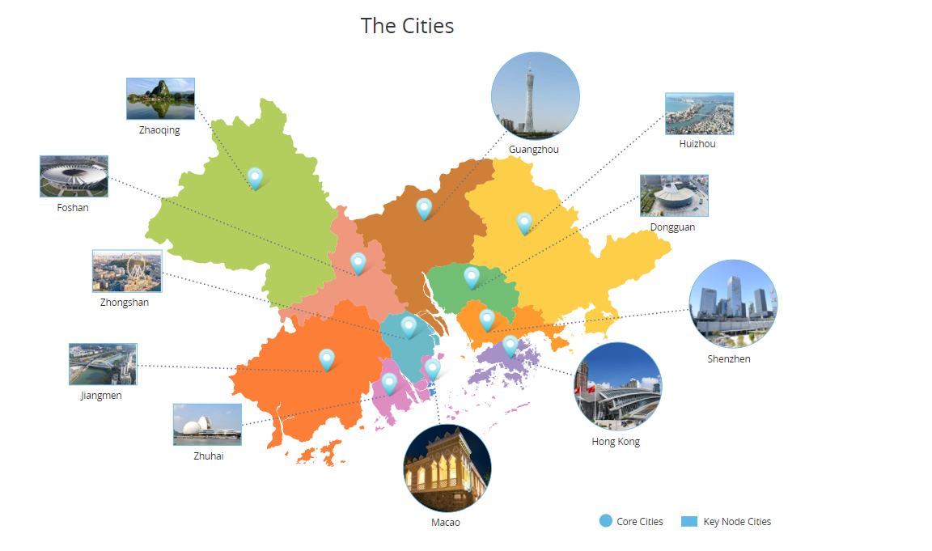

**Module 2.4 Economic Performance and Human Resources of Hong Kong**

**Part 2：Opportunities and challenges brought by**

**Economic Globalisation to Hong Kong**

**(Lesson 7)**

**Learning and Teaching Materials**



**The role of Hong Kong in the economic development of our country**

Since its return to the motherland, Hong Kong has been expanding its areas of cooperation with the Mainland and striving to escalate the level of joint efforts. In the Outline of the 14th Five-Year Plan for National Economic and Social Development of the People’s Republic of China and the Long-Range Objectives Through the Year 2035 (“National 14th Five-Year Plan”) promulgated in March 2021, its contents relating to Hong Kong incorporated many concrete proposals put up by the HKSAR Government after thorough studies, demonstrating the Central Government’s unwavering support for Hong Kong. The National 14th Five-Year Plan establishes a clear positioning for Hong Kong’s future development as embodied in three major aspects: First, it is mentioned to uphold the “one country, two systems” principle as well as safeguard national security in order to maintain the long-term prosperity of Hong Kong; Second, it is mentioned to support Hong Kong in reinforcing and enhancing its competitive advantages, including the continued support for Hong Kong to maintain its status in the “**four traditional centres**”, namely **international financial, transportation and trade centres** as well as **centre for international legal and dispute resolution services in the Asia-Pacific region**, and raised for the first time the support for Hong Kong to enhance, establish and develop the **“four emerging centres”, namely an international aviation hub, an international innovation and technology centre, a regional intellectual property trading hub and an East-meets-West centre for international cultural exchange**; Third, it is mentioned to support Hong Kong in better integrating into the overall development of the country, emphasising the support for building a high-quality **Guangdong-Hong Kong-Macao Greater Bay Area**. The National 14th Five-Year Plan confirms Hong Kong’s functions and positioning in the overall development strategy of the country, provide a clear direction and expand the scope for Hong Kong’s further co-operation with the Mainland.

By strengthening cooperation with the Mainland, Hong Kong can leverage its unique advantages in our country's development strategy and help facilitate coordinated economic development in the Mainland, and contribute to national reform and development. At the same time, Hong Kong's economic structure can be perfected and upgraded and our understanding of the national development deepened.

Sources: Constitutional and Mainland Affairs Bureau Website

<https://www.cmab.gov.hk/en/issues/regional_cooperation.htm>

Watch the following TV programmes to understand the National 14th Five-Year Plan:

* TV programme: Vision of the Fourteenth National Five-Year Plan (Chinese only)

Episode 1: Hong Kong’s New Vision

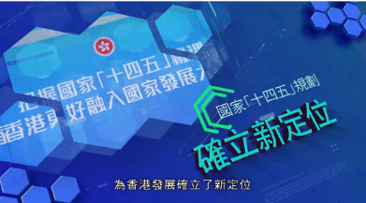

(Other episodes: Episode 2: International Transportation Centre, Episode 3: International Financial Centre. Episode 4: International Aviation Hub, Episode 5: International Innovation and Technology Hub, Episode 6: Hub for Arts and Cultural Exchanges between China and the rest of the World, Episode 7: Regional Intellectual Property Trading Centre, Episode 8: Centre for International Legal and Dispute Resolution Services in the Asia-Pacific Region, Episode 9: International Trade Centre  
Episode 10: Greater Bay Area and the “Qianhai Plan”)

Source: Constitutional and Mainland Affairs Bureau Website: The HKSAR's Work in Complementing the National 14th Five-Year Plan

<https://www.cmab.gov.hk/en/issues/14th_5yrsplan_index.htm>

**Extended Reading**

**Factsheets on “Outline of the 14th Five-Year Plan for National Economic and Social Development of the People’s Republic of China and the Long-Range Objectives Through the Year 2035”: International Financial Centre**

(Other factsheets: International Transportation Centre, International Trade Centre, Centre for International Legal and Dispute Resolution Services in the Asia-Pacific Region, International Aviation Hub, International Innovation and Technology Hub, Regional Intellectual Property Trading Centre, East-meets-West Centre for International Cultural Exchange)

Source: The Chief Executive’s 2021 Policy Address Website

<https://www.policyaddress.gov.hk/2021/eng/related-publications.html>

**Reference**

Constitutional and Mainland Affairs Bureau

<https://www.cmab.gov.hk/en/>

Census and Statistics Department

<https://www.censtatd.gov.hk/en/>

Hong Kong Monetary Authority

<https://www.hkma.gov.hk/eng>

World Trade Organization

<https://www.wto.org/>

The World Bank

<https://www.worldbank.org/>

International Monetary Fund

<https://www.imf.org/en/Home>

Department of Sociology, the Chinese University of Hong Kong (Chinese only)

<https://www.cuhk.edu.hk/hkiaps/pprc/LS/globalization/2_c.htm>

The Academy of Chinese Studies

<https://ls.chiculture.org.hk>

